**Maryam Habib Tarrada** 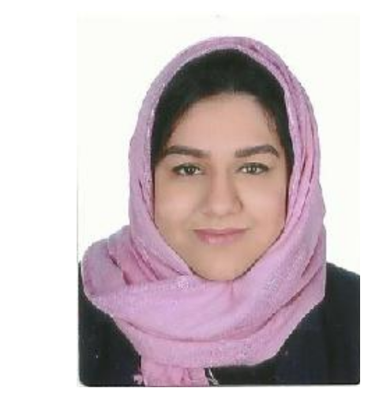

**4th of Jun 1997**

**39901966-39722122  
drawmemo97@gmail.com**

**OBJECTIVE**

I would like to obtain a position that will enable me to use my strong organizational skills, educational background and ability to work well with people, as I am a hardworking person and have adequate communication skills.

**EDUCATION**

* B.Sc Banking and finance (2015-present)

University of Bahrain, Bahrain

* Secondary School Certificate (2014-2015)

Alshorooq Secondary School, Bahrain

**Professional Certificates / Other Qualifications**

IELTS Certificate (6)

First Aid Certificate

**Experience**

* Abu Ahmed stationary

Cashier, designer, data administrator, report writing (1/9/2018 to 27/12/2018)

* Howayte

Social media manger ( 1/7/2017 to 30/7/2017 )

* Sale for Distribution and Communication Co.Ltd :

Promoter (3 July 2016 to 31 August 2016)

* Sale for Distribution and Communication Co.Ltd :

Data administrator (28 June 2015 to 27 August 2015)

* Community service:

Receptionist in physical therapy, Salamaniya hospital

**Achievements**

Attended world Islamic banking conference 2018 (WIBC2018)

**Skills**

Excellent computer skills

Adequate communication skills

Fluent spoken/written English & Arabic skills

Excellent data analysis skills

**Hobbies**

Drawing and designing

Learning new languages

Writing and reading

**Reference**

Available upon request